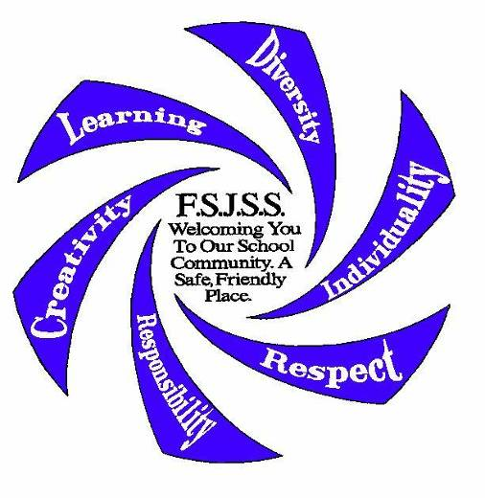FALCON FLYER

Apr. 17, 2025

*Fort St. James Secondary School*

P.O. Box 220 V0J 1P0

Telephone: 250-996-7126 Fax: 250-996-7708

Principal – Craig Houghton: [choughton@sd91.bc.ca](mailto:choughton@sd91.bc.ca)

Vice-Principal – Shelley Leatherdale: [sleatherdale@sd91.bc.ca](mailto:sleatherdale@sd91.bc.ca)

**DATES TO NOTE:**

Apr. 17 Term 3 ends

Apr. 18 Good Friday STAT– students do NOT attend school

Apr. 21 Easter Monday STAT – students do NOT attend school

Apr. 22 Term 4 begins

Apr. 28 Report Cards sent home

May 1 Recognition Assembly @ 9:00 am

May 7 Wellness Fair in Old Gym

May 8 PLC – Early Dismissal @ 12:15 pm

May 9 Pro D – Students do NOT attend school

May 15 Newsletter goes out

June 20 Grad Ceremony @ 1:00 pm

**A MESSAGE FROM OUR PRINCIPAL**

Time is flying by, and third term reports cards will be out the end of April.  This is a very important time for our grade 12 students to stay focused on the goal of graduation.

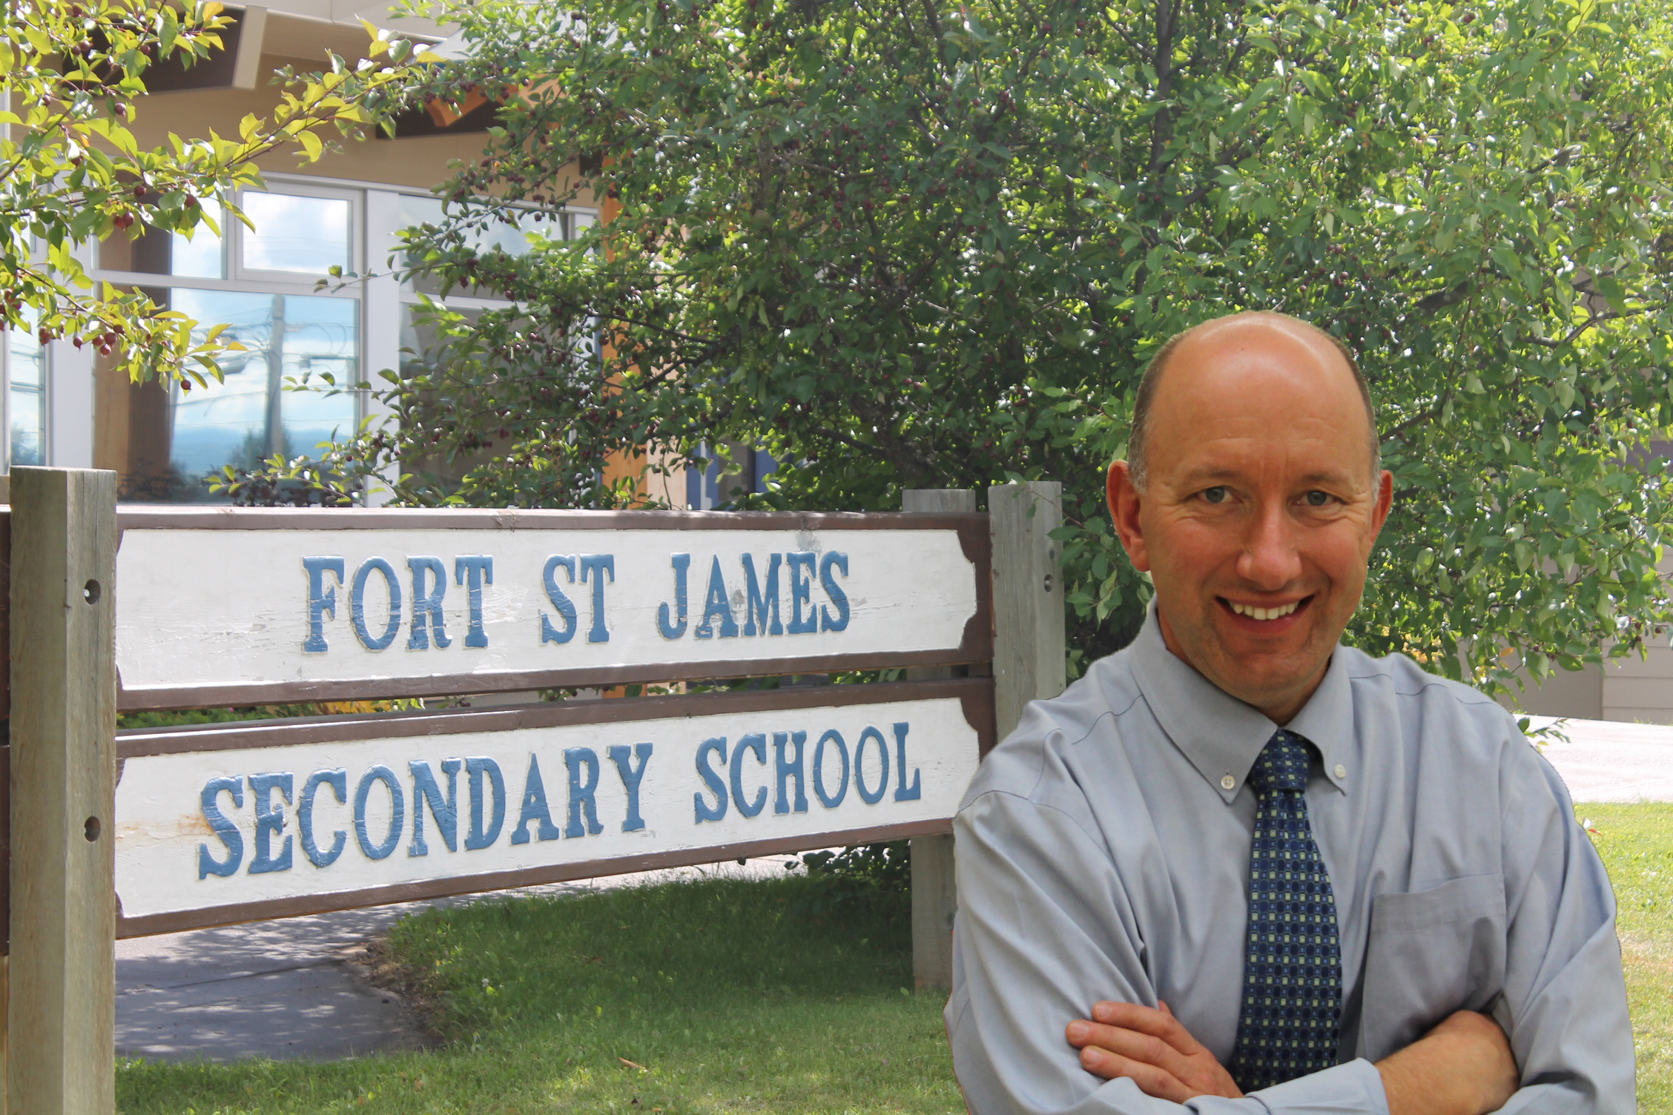

As always, FSJSS students are very busy.  The Girls Soccer and the Mountain Bike teams are well into their season.  Environmental Studies students are out in the field again taking water samples and stream flow rates.  The

Grade 8 Science students will be going to the mine soon to learn about environmental management.

Students have completed their course selection requests for the 2025-2026 school year, and we are busy building the new timetable.  It is wise for families to discuss the courses that students are taking to be sure the best choices are made.  Take some time to go outside and enjoy activities with family and friends.

Mr. Craig Houghton, Principal, FSJSS

**ATHLETIC COSTS**

**REMINDER:** Please remember to pay your Athletics fee. All students who join any team must pay $50 for the first team. Each additional team they play on then costs $10 more.

**ACCOUNT STATEMENTS**

Just a reminder that all accounts must be paid in full before students are allowed to participate in the Graduation Ceremony.

**FALCON FLYER INFORMATION**

If you would like a copy of the Falcon Flyer e-mailed to you directly, please e-mail [bthiessen@sd91.bc.ca](mailto:bthiessen@sd91.bc.ca)

or you can view it on our Facebook page under Fort St. James Secondary School.

**SCHOOL CONCESSION**

Our school concession serves lunch every school day. All meals are $6.00 with the exception of pizza, which is $3.00 a slice or 2 slices for $5.50. The menu is posted on the concession white board and the TV’s.

**FRIDAY NIGHT MOVIES**

Please see the school Facebook page for the weekly movie. Admission is $10 per person,

doors open at 6:30 pm with the movie starting at 7:00 pm.

**PLC DAYS for 2024-2025**

The following are our PLC days. Students will be dismissed at 12:15 pm.

May 8

**GRADUATION:** Grad Ceremony will be held on June 20th @ 1:00 pm. More information to come in May’s newsletter.

**SCHOOL BOARD OFFICE NEWS**

**Student Learning Survey 2024/2025**

The Provincial Student Learning Survey is unique in its scope, size and usefulness to schools. It gathers information from parents/guardians/caregivers, teachers, and students on topics related to school environment, safety, and achievement. The information is used for planning in individual schools and provides a district and provincial perspective.

Early in **2025** the Student Learning Survey will be administered to students in grades 10, 11, and 12, their parents/guardians/caregivers, and all school staff. We encourage parents/guardians/caregivers to participate in this survey, as the results are important in identifying and celebrating current strengths, as well as determining where the school needs to focus improvement. The surveys contain standard questions for the Province – in addition, questions from the school and/or district that focus on local conditions or issues may be included.

The survey can be completed electronically and can be accessed on the Internet at <https://www2.gov.bc.ca/gov/content/education-training/k-12/support/student-learning-survey>. Any computer or mobile device with an Internet connection can be used, and access to the e-survey is simple and secure. The survey can be accessed through the link and by clicking on Take the Survey. On the login page, click on the Parents icon, and then select School District 91 and then the school where your child attends, Fort St. James Secondary School. Provincial, District and School Reports for previous years can be viewed at the same site under the *Results* section.

The e-survey site will be open until May 2, 2025.

If you have any questions, please contact the school at 250-996-7126.

**GRAD COUNSELLING NEWS**

**Post-Secondary Application Deadlines**

Grads that have missed the application deadlines for Post Secondary Schools can still apply for general studies. Students may still be admitted if there are open spots.

Grads need to regularly check their post-secondary emails to ensure they do not miss important deadlines for housing, payments, and course registrations.

**Online Courses**

Grads **completing online courses** should aim to have them **completed** by **May 31, 2025,** to ensure they are included on their final transcripts.

**Scholarships/Bursaries**

If students have any questions about scholarships or bursaries, they can see Ms. Deverson or Ms. Houghton. The list of district scholarships and bursaries are now available to view online, as well as in the library. Students should check out the “Scholarships” folder in the student shared drive for more information on how to apply for the various scholarships and bursaries, as well as print off the application forms.

Scholarship packages are due **APRIL 30, 2025. They are to be put in Ms. Deverson’s mailbox in the office.**

**Numeracy & Literacy Exams THESE ARE GRADUATION REQUIREMENTS**

Click on the link attached below for Assessment descriptions and samples

[**https://www2.gov.bc.ca/gov/content/education-training/k-12/administration/program-management/assessment/graduation**](https://www2.gov.bc.ca/gov/content/education-training/k-12/administration/program-management/assessment/graduation)

The next available times for writing include:

**June 2-13, 2025**

**Athletics 2024/25**

**Jr. Girls Soccer**

The team has started practicing on Tuesday’s and Thursday’s at 3:30PM.  They will be travelling to Clearwater at the end of the month.

**Sr. Girls Soccer**

The team travelled to Kamloops for a Futsal tournament and did very well with 5 wins and 1 loss.  They have also travelled to Osoyoos.  In Osoyoos they beat Kelowna Christian and Abbotsford Christian.  They lost to the very strong AAA George Elliott and Aberdeen Hall from Kelowna.  Next up are the Oliver and Merrit tournaments, as they prepare for Zones.

**Mountain Biking**

This year we have 5 riders training and preparing for the Provincial Championship Races in Powell River after the May Long Weekend.  Thank you to Erica and Blake Olesiuk for taking on the coaching and driving duties for this team.

**Coaches**

We would like to thank Chris Greenaway and Martina Jones for dedicating many years of coaching at FSJSS.  Chris coached 14 years at FSJSS including many years as a basketball coach and then he moved to Mountain Biking.  Martina has spent the last 8 years coaching Mountain Biking.   We would also like to thank Ryan McVey who has spent the last 8 years coaching boys and then girls’ basketball.  It is people like these three that make our Athletics program so successful for a small school.  They have touched the lives of many students and provided opportunities for our students to excel in the sports they love.  THANK YOU!

We are excited to announce that Erica Olesiuk has accepted the coaching position for our Sr. Girls Basketball team for next year.  Erica has been coaching at our school for the past few seasons.  She is excited to be moving up with the girls.



[This Photo](https://ftygam.blogspot.com/2019/02/football-game-clipart-black-and-white.html) by Unknown Author is licensed under [CC BY](https://creativecommons.org/licenses/by/3.0/)

